 | volume-8 Issue-2  ISSN:2348-2079  International Journal of Intellectual Advancements and Research in Engineering Computations

Perspective indication and smart penalty system for road transportation

Dr. J. Sharmilee¹, J. Adlenepriyatharisini², R. Divya³, T. Mohan Raj⁴, K. Vishakan⁵
¹Assosciate Professor, Department of Electronics and Communication Engineering, Nandha Engineering College (Autonomous)
^{2,3,4,5}UG Student, Department of Electronics and Communication Engineering, Nandha Engineering College (Autonomous)

ABSTRACT
Preventing general traffic violation is not easy in roads or urban streets due to the inattentive drivers. Traffic rule violation leads to accidents and may even cause life death. In this paper, we present an intelligent traffic violation detection to monitor red light jumping. This system is based upon Radio Frequency Identification (RFID) technology for the identification of vehicles on the road. This system also generates the penalty for vehicles jumping red light and sends generated penalty to that concerned person.

INTRODUCTION
The main objective of the project is to charge the penalty for the concern person who violating the traffic rules. This technique is done by RFID, RF READER, ARDUINO UNO and UBIDOTS. Automatic generation of notification to the concerned authorities via SMS (short message service) is including penalty charges. RFID based technology is used for identifying the vehicle drivers who violating red light signal. On detecting the violation, the system reads the unique RFID of the vehicle and sends the penalty charge notification to the concerned person. This system, easily identify the vehicle drivers who violating the rules. Less traffic congestion and efficient mechanisms used to control accidents [1, 2].

LITERATURE SURVEY
“Real time traffic information service using terrestrial digital multimedia broadcasting system” Sammo Cho, Kim Geon, YounghoJeong, Chung-Hyun Ahn, Soo In Lee, and Hyuckjae Lee. This paper is the implement of real time traffic and traveler information service through the Terrestrial Digital Multimedia Broadcasting. In this system they use mobile data service to transmit the information both audio as well as video. It is Korean characteristics implement action they used the transport protocol expert group to share the information. This technique was adopted by all over the European countries. “Image Analysis and Rule-Based Reasoning for a Traffic Monitoring System,” Rita Cucchiara, Member, IEEE, Massimo Piccardi, Member, IEEE, and Paola Mello This system which monitors the vehicles on the rule based reasoning on the traffic monitoring system. Here the picture of the vehicle was capture by the surveillance camera. The picture can be classified into high and low level images. Both the images were analyzed by the AI technique hence the higher and lower quality of the image was processed and thereby it provides the system with flexibility and robustness.
“Bandwidth Optimization for Internet Traffic in Generalized Processor Sharing Servers,” Ju Yong Lee, Sunggon Kim, Deokseong Kim, and Dan Keun Sung, Senior Member, IEEE. This paper presents the detail about the internal traffic served by GPS. Internal traffics are difficult to control and analysis. GPS is used as the tool to identify the traffic congestion and jams. Identifications help to charge the penalty for the concerned person through messages. The penalty system is used for local areas not for the global optimization. “Modeling and detecting aggressiveness from driving signal”, Ana BelénRodríguezGonzález, Mark Richard Wilby, Juan José VinagreDíaz and Carmen Sánchez Ávila. The advance driving system like Google car which provide a curial construction of future intelligence system which highly reduces the accidents. We can monitor the aggressive driving but external driving by latitude, longitude and acceleration of the vehicles. This can done by real driving a vehicle there by it’s diagnosed and learn the aggressive driving for further detections. The classifier in this technique were detect the aggressive driving a generated success result up to 92.2%
“Looking at vehicles on the road: A survey of vision- based vehicle detection, tracking, and behavior analysis” SayananSivaraman, Member, IEEE and Mohan ManubhaiTrivedi, Fellow, IEEE. This paper will provide the review of the literature in road and vision based vehicle system, detection and behavior understanding the sensor which sense advance vehicle detection and discussing the monocular activities. It includes the direction of the art.

EXISTING SYSTEM
The world is rapidly urbanizing. The population increases day by day. Because of that vehicle usage of the people increases rapidly. There are n number of accidents happened because of the traffic jams, street intersections and violation of red signal. There is no proper planning to control the violations. The government introduced the technique which is fully based on the image processing. The driver who violating red signal, the system capture the image of the vehicle and helps to identify the number plates of the vehicle [3, 4].

DRAWBACKS OF EXISTING SYSTEM
- Identification through the video processing does not have greater accuracy.
- Penalty provided for violating signal was done by man power.

PROPOSED SYSTEM

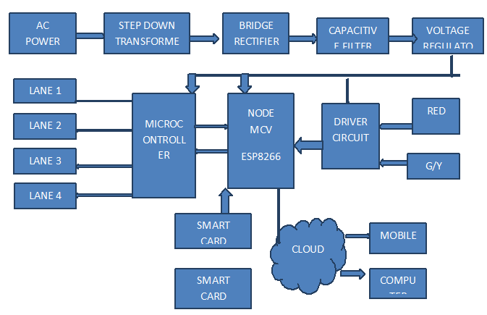
Fig1. System block diagram

In proposed system, the RF Reader is fixed at the traffic signal. The RFID tag is fixed in the vehicle (fast tag). The range of the RFID is extended up to the give way line of the road when the red signal gets ON, the RF Reader which gets starts detect. If it detect any fast tag (RF tag) of a vehicle during the red signal, it drag the information and charges the penalty for the concerned person via SMS, Mail and Telegram.when the green signal is turned ON then the RFID turned off [5, 6].

FUNCTIONAL DESCRIPTION

ARDUINO NANO
It is the small and complete board of ATmega328p.It lacks on dc power jack works with mini USB cables. It contains 32 pins. It is available in the form of TQFP (plastic quad flat pack).

Node MCU (ESP8266)
The development board equips the ESP-12E module containing ESP8266 chip having Tensilica Xtensa 32-bit LX106 RISC (Reduced Instruction Set Computer. Microprocessor which operates at 80 to 160 MHz adjustable clock frequency and support RTOS (Real Time Operating System).

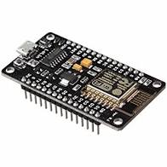
Fig2. NODE MCU (ESP8266)

RF Reader EM218
The devices which use RF signal to transfer the data to RF tag. It is used to read the tags. It is one of the major components in RFID technology. It is used in the places like office, college and industry.

RF Tag 125 KHZ
It receives the data from the RF reader. It contains three parts transponder, transmitter and receiver. There are two types of tags available one is active and another is passive tag. Based on the frequency level the tag is used.


Fig3. RF TAG 125 KHZ

Relay module
It is the switching device. It helps to open and close the circuits electronically. It is used to
control the high voltage circuits with the low voltage signal.

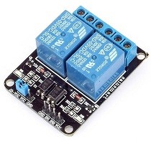
Fig4. Relay Module

LED (Light Emitting Diode)
In our proposed system LED is used for the lanes. It plays major role in our system. Because of
the led we easily identify the red light violation. Very low voltage is enough to drive the LED.

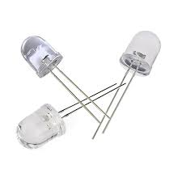
Fig5. LED

ARDUINO IDE
It is the platform to code for an Arduino. In this environment, typing program translated into code. The programs like c, c++, python and other high-level language. IDE is easy to code and upload in the Arduino. It runs in the platforms like windows and Linux. It contains the functions like edit, file, sketch, tools and help, library also available in the ARDUINO IDE.

UBIDOTS
The platform which is used to send and receive the data from the cloud with the help of IOT it store, retrieve and compute the data. Secure connections made with (HTTP, TCP and UDP) protocols. It is used in educational purpose and industry purpose to store and receive the data.

CONCLUSION AND FUTURE WORK
Road Transport and Highways Ministry of India has increased the penalties for traffic rule violations across the country. Traffic congestion is a major problem in many cities of India along with other countries. Failure of signals, poor law enforcement and bad traffic management has lead to traffic congestion. The problem with the existing systems is that the installation time, the cost incurred for the installation and maintenance of the system is very high. Hence a new technology called Radio Frequency Identification (RFID) is introduced which can be coupled with the existing signaling system that can act as a key to smart traffic management in real time. This new technology which will require less time for installation with lesser costs as compared to other methods of traffic congestion management. Use of this new technology will lead to reduced traffic congestion.

REFERENCE
- C. Caligaris, S. Sacone, and S. Siri, “Multiclass freeway traffic: Model predictive control and microscopic simulation,” in Proc. 16th Mediterranean Conf. Control Autom., Ajaccio, France, 2008, 1862–1867.
- K. Aboudolas, M. Papageorgiou, A. Kouvelas, and E. Kosmatopoulos, “A rolling-horizon quadratic-programming approach to the signal control problem in large-scale congested urban road networks”, Transp. Res. C, Emerging Technol. 18(5), 2010, 680–694.
- S. K. Zegeye, B. De Schutter, J. Hellendoorn, E. A. Breunesse, and A. Hegyi, “A predictive traffic controller for sustainable mobility using parameterized control policies”, IEEE Trans. Intell. Transp. Syst. 13(3), 2012, 1420–1429.
- M. Hadiuzzaman and T. Z. Qiu, “Cell transmission model based variable speed limit control for freeways”, Can. J. Civil Eng. 40(1), 2013, 46–56.
- G. C. K. Wong and S. C. Wong, “A multi-class traffic flow model- An extension of LWR model with heterogeneous drivers”, Transp. Res. A, Policy Pract. 36(9), 2002, 827–841.
- M. J. Lighthill and G. B. Whitham, “On kinematic waves. IIA theory of traffic flow on long crowded roads”, in Proc. Roy. Soc. London A, Math. Phys. Eng. Sci. 229(1178), 1995, 317–345.

