 | volume-9 Issue-2  ISSN:2348-2079  International Journal of Intellectual Advancements and Research in Engineering Computations

Design and analysis of disc brake using ansys

¹Mr.Gowtham J L, ²Dr.Saravanan P, ³Mr.Arulraj R
¹PG Student, Department of Mechanical Engineering, MEC, Mallasamudram, Namakkal DT - 637503
²Head of the Department, Department of Mechanical Engineering, MEC, Mallasamudram, Namakkal DT - 637503
³Assistant Professor, Department of Mechanical Engineering, MEC, Mallasamudram, Namakkal DT - 637503

ABSTRACT
Automotive braking systems usually consist of stainless steel or Gray cast iron. These materials are ideal for use in automatic transmissions with moderate loads as well as low heat resistance, as they have high contrasting stiffness & stability, low wear rate, & are quiet while in use. The integrated brake discs are smaller, more economical & have excellent collision features. In our project the Hyundai car model disc brake model that creates Creo parametric software and structural-based analysis using Ansys software. Existing metal is replaced by a compound (Kevlar & Carbon Fiber). Predicting deformation, amount of stress intensity using Ansys software.
Keywords: Composite Disc Brake, Kevlar & Carbon Fiber, Creo Parametric & Ansys Software

INTRODUCTION
Disc brakes are used in many new automobiles. They get their based on the fact that they slow the car by applying force to the discs devoted to the wheels. Disc brakes have a better grip strength than drum brakes & do not burn out as rapidly under heavyweight use. While some entry-level cars use drum brakes on the rear wheels, four-wheeled disc brakes are widely available for everything from family sedans, trucks, and active sports cars.
A circular disc is attached to a rotating wheel hub. Rotors are usually made of cast iron or steel, but some high-end cars use a carbon ceramic rotor. Rotors can be mounted or fastened to provide better heat.

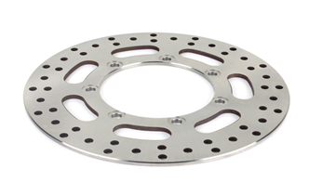
Fig. 1 Rotor

LITERATURE REVIEW
The analysis was performed using the simulation of FEA software solid works. A variety of material structures have been used to study the stability of the static load of the disk brake. 1000N load applied to disk brake under normal conditions. Pressure, migration and difficulty are found, so it is presented [1]. [2] When the brake applied to the disc brake is subjected to high pressure, structural & wear problems can arise. To choose lower stress factors, better efficiency, structure, pressure, & thermal analysis are recommended. The aim of this study is to model as well as analyse the disc brake disc's pressure concentration, structure, & gradient. The disc brake is constructed from solid materials, & the research is carried out using the ANSYS R14.5.
Many trucks and buses have air actuated caliper disk brake brakes. The maximum contact power is mechanically transmitted with a device equipped with a needle that works according to size. Simple action, fully enclosed guides between the axial steering wheel and the constant brake anchor plate are ignored. There are no brake clusters, external levers, or cylinder brackets, as the brake cylinders are firmly attached, presented [3, 4] commonly rotor iron is used for disc brake and is now used for stainless steel of the day. In order to improve the performance of brake disc equipment it is important. By looking at the attached text, complete the required brake structures. It is evident that the brake effect of the brakes is very good for the new compact AMC 6061.
[5] is a carbon ceramic matrix disc brake material that calculates the normal force, shear strength and piston force and includes the brake disc brake distance. A standard model of two brakes using Ansys, performed Thermal and Modal Analysis calculates deviation, total temperature, frequency and disc brake model temperature. This is important to understand the potential and impact of disc brake new material, using efficient disc brakes, which can benefit decrease the risk that can occur to each day. In order to study and be made [6] of various design patterns of various materials we have seen that the high temperature of the metal forecast is very small compared to stainless steel so on the basis of analysis, cast iron is the finest for producing disc brake. However cast iron disc brake suffers from recurrence when exposed to moisture so it cannot be used on two wheels so we prefer stainless steel.
Design & analysis of Disc Brake with a different pattern of holes made for various materials such as Structural Steel, Aluminum Alloy and Stainless Steel with different disc models in various sizes. The pattern M1, D1, T3 (Structural Steel, Star Shaped hub with Circular and Triangular hole, with 6 mm thickness) is found as a very well-made pattern compared to all the other 9 patterns discussed [7]. The profiles of [8] made of Cast iron also have a better degree of heat dissipation but the tendency of the metal to deteriorate when exposed to water or moisture. It is therefore not suitable for production purpose. The maximum temperature obtained for a steel iron disc brake is 56.93℃ and the temperature drop is 33.67℃. The maximum temperature available on a non-slip disc brake is 69.81℃ and a temperature drop of 25.64℃. High temperatures are found in the stainless-steel disk so this item is ready for construction.
The three available materials, namely stainless steel, cast iron & carbon-carbon composite, are related to vanadium to ensure high consistency, tension and temperature. Disk brakes are modeled using Creo 3.0 & analysis is performed on ANSYS 15.0. Upon completion of the analysis, Vanadium Steel was shown to have better thermal resistance properties than the other three factors discussed [9]. Thermal compression, hardening and deformity of the disc brake rotor with AMMC material are presented [10]. In all probability, an AMMC will exhibit the desired effects of a disc brake rotor (opened by molded holes) that binds to high thermal stress caused by a collision between the brake pad and the surface of the disc rotor & also dissolves heat produced at a rapid rate. Therefore, AMMC material is popular due to its small shrinkage, high hardness and pressure and high temperature compared to other materials.

WORKING METHODOLOGY
- Disc Brake Study
- Problem Identification
- Material Selection
- Disc Brake Design using in Creo Parametric Software
- Structural Analysis using in Ansys Software
- Result & Comparative
- Conclusion

PROBLEM IDENTIFICATION
Brakes are a very important part of the braking system in stopping all moving parts, including braking speed, sharp grip, traffic congestion, and downsizing. Different effects of pressure occur in flexible binding times that result in lower wear and strength ratios. These effects should be minimized by using a composite disc brake.

OBJECTIVE
In this project the fiber material could be replaced with existing material of disc brake. Carbon fiber and aramid fiber has selected as raw material for the proposed composite disc brake.
- To analysis the mechanical characteristics of composite material by using ANSYS software
- To determine material stress and deformation for Carbon Fiber and Kevlar Fiber.

Table 1 Material Properties
Description | Units | Steel | Kevlar | Carbon
Density | kg/m³ | 7850 | 1440 | 2000
Young’s Modulus | GPa | 200 | 112 | 228
Poisson Ratio | - | 0.3 | 0.15 | 0.36

DESIGN & ANALYSIS OF DISC BRAKE
The usage of computers (or operating systems) to aid in the design, modification, research, or optimization of a design is known as CAD. Designer efficiency, design consistency, textual communication, and the development of a production database are all aided by CAD software. Electronic files for printing, machinery, as well as other operations are popular CAD launches.

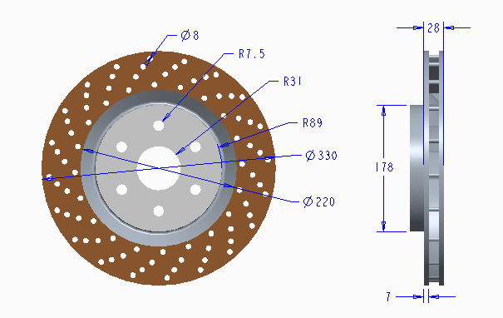
Fig. 2 Disc Brake Model with Dimension

The FEM is a mathematical method for solving difficulties that are defined by split equations or can be established as performance reduction. FEA is one of the pricing methods for finding a limited solution to govern equation by dividing a large region into smaller regions. The lower regions are called extinct elements. The process of separation is called meshing.

.Further, disc brake model analysis based on the static structural in Ansys software. To predicted deformation, stress, stress intensity and shear stress in all the material. Comparatively analysis result show in the Table.

Table 2 Comparison of all the material analysis data
Description | Unit | Steel | Carbon | Kevlar
Deformation | mm | 0.011611 | 0.0098216 | 0.021635
Stress | Mpa | 7.8532 | 7.287 | 8.8204
Stress Intensity | Mpa | 8.8813 | 8.3035 | 9.7595
Shear Stress | Mpa | 2.6329 | 2.313 | 3.2779

To observe the table, comparatively carbon fiber is better result. Its reason is all the predicted result is low compared to the other material. The carbon fiber analysis image show in the below Figure.

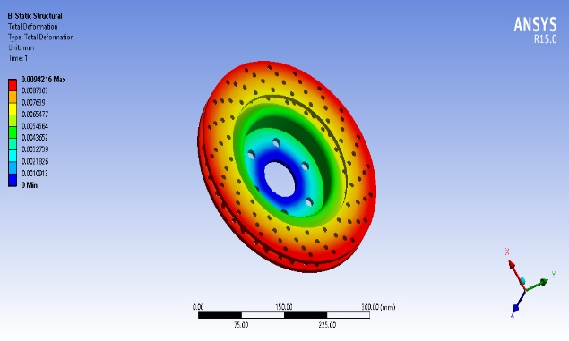
Fig. 3 Deformation in Carbon Fiber

The carbon fiber material is low weight compared to the steel material. To predicted deformation 0.0098216mm and show in the Figure

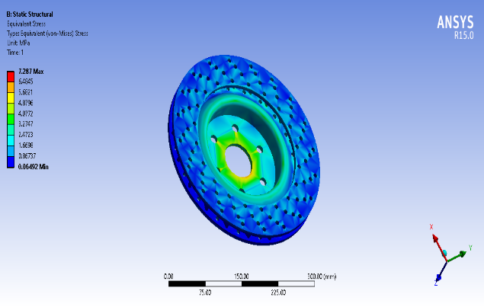
Fig. 4 Stress in Carbon Fiber

The stress is based on load and area, so it’s predicted the stress value is 7.287MPa in carbon fiber and show in the Figure.

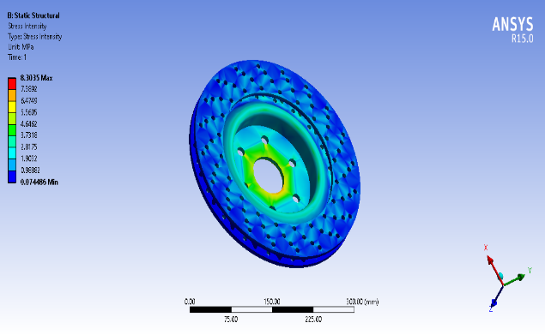
Fig. 5 Stress Intensity in Carbon Fiber

Stress intensity is nothing but fracture stress value, it’s to disc brake model with carbon fiber material predicted the stress intensity value is 8.3035MPa obtained and show in the Figure.

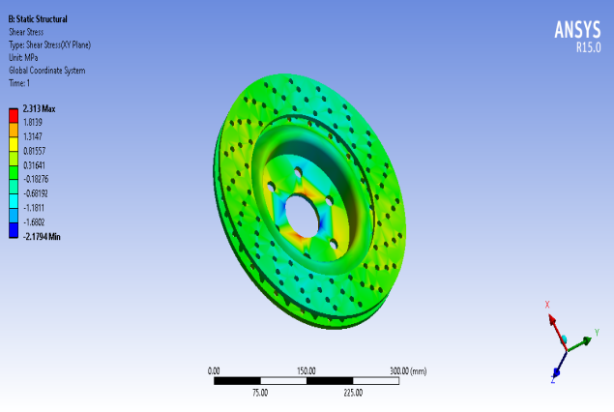
Fig. 6 Shear Stress in Carbon Fiber

Generally, shear stress 2.313MPa value is obtained and mention in the Figure.

Advantages
- It has a greater mechanical benefit.
- Because of the hydraulic pressure, it has greater stopping power & a shorter stopping distance.
- The disc rotor has a higher heat resistance capability. Also, because of the improved heat dissipation, the cooling rate is higher.
- It is less difficult to maintain.

Applications
- Since the speed of higher-cc performance bikes is higher, better stopping power is needed.
- New cars have disc brakes on the front or all four wheels.
- Mountain bikes & bicycles are two of the most common modes of transportation.

CONCLUSION
In our project we have designed a Disc brake rotor analysis of different materials Steel, Kevlar fiber & Carbon Fiber. When comparing the deformation & stress values of the three materials for 7mm thickness, it’s based on structural analysis and also, weight of the carbon fiber reduces almost 3 times compared with steel since its density is very less. Thereby mechanical efficiency will be increased. Comparatively carbon fiber is better material using disc brake (deformation 0.0098216mm & stress 7.287Mpa).
.

Reference
- Kamana Vishnu Vardhan Chowdary & Subhramanyam “Design & analysis of a disc brake” Inter. J. of Professional Engg. Studies, 5(5), 2015, 236-243
- Rakesh Jaiswal, Debayan Das, Pawan Jaiswal, Anupam Raj Jha, Anush Karki, Saurav Rajgadia & Ankit Basnet (February 2016) “Structural & thermal analysis of disc brake using solid works & ansys” Inter. J. of Mech. Engg. & Tech., 7(1), 2016, 67-77
- Vishlawath Raju & Pranathi “Design & analysis of disk brake” Inter. J. & Magazine of Engg., Tech., Management & Research, 4(1), 2017, 480-487
- Sagar Porlekar, “Design, analysis & optimization of brake disc made of composite material for a motor cycle”, Inter. J. of Research Publications in Engg. & Tech., 3(3), 2017, 63-69
- Soumya Ranjan Parmanik, Subhrasnat Rout, Ravi Kumar, Shenwaz, Mohsin Ansari, Santosh Jha, “Design & analysis of disc plate of an all-terrain vehicle” Inter. J. of Scientific Dev. & Research, 2(4), 2017, 250-253
- Sumeet Satope, Akshaykumar Bote & Swapneel Rawool, “Thermal analysis of disc brake” Inter. J. for Innov. Research in Sci. & Tech., 3(12), 2017, 68-73
- Sainath Chary & Anoop Kumar, “Design, analysis & fabrication of disc brake using various pattern of holes” Inter. J. of Current Engg. & Scientific Research, 4(11), 2017, 99-104
- Avinash Singh Thakur & Dhakad “Thermal analysis of disc brake using ANSYS” Inter. J. of Tech. Innov. in Modern Engg. & Sci., 4(6), 2018, 8-17
- Chetan Kale & Ganesh Kesheorey, “Design & analysis of disc brake” Inter. J. for Research Trends & Innov., 4(5), 2019, 98-101
- Praharsha Gurram, Shravan Anand Komakula, Vinod Kumar “Design & analysis of vented disc brake rotor” Inter. J. of Applied Engg. Research, 14(9), 2019, 2228-2233

